**HW4 Report**

1. Page 1: **(10 points)** A plot of the mean image for each class.

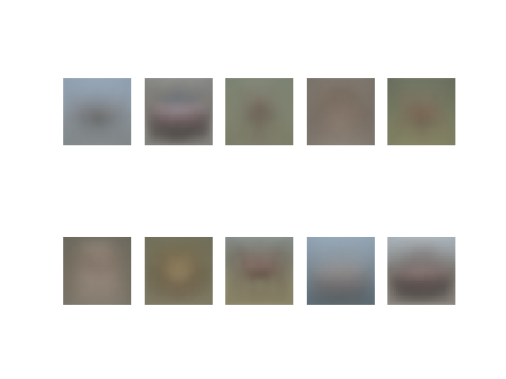

1. Page 2: **(15 points)** A plot of the average sum of squared pixel-wise difference between the reconstructed and original images of each class **as a bar graph** vs. the class label.

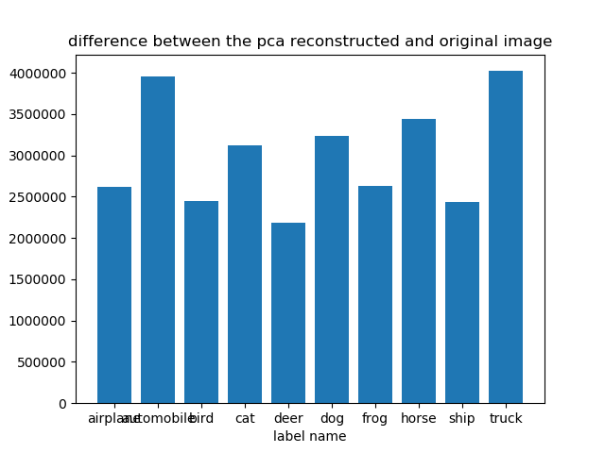

1. Page 3: **(25 points)** The 2D scatter plot obtained after performing principal coordinate analysis using euclidean distance.

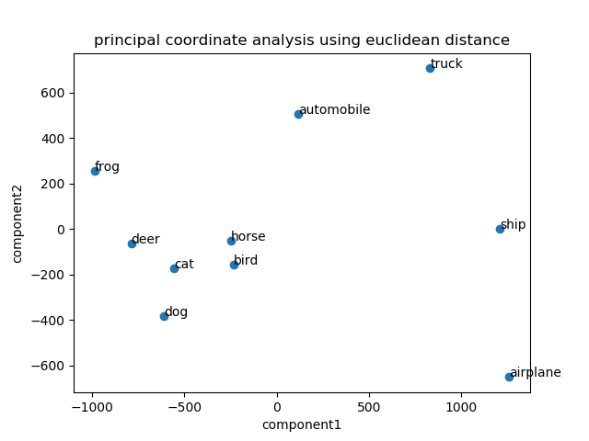

1. Page 4: **(25 points)** The 2D scatter plot obtained after performing principal coordinate analysis using the similarity metric in part C.

